Guide to electronics

A)  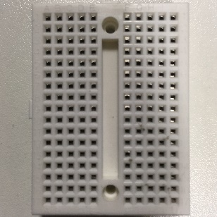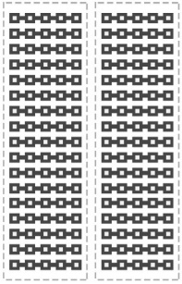 |  |  | Breadboard  Building circuits
B)  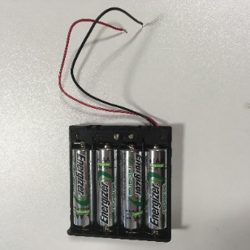 | Battery pack  Provide power  Red is positive  Black is negative | C)  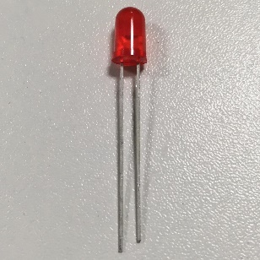 | LED  Emits light  Long leg is positive  Short leg is negative
D)  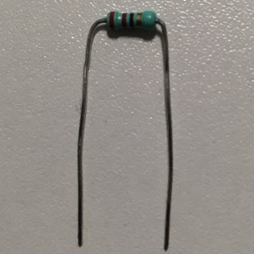 | Resistor  Limit current passing through circuit | E)  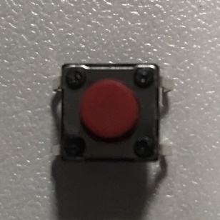 | Button/Switch  Connects circuit when pressed
F)  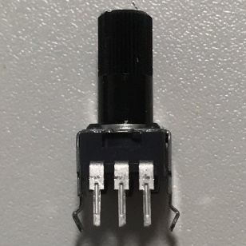 | Potentiometer  Controls current flowing through circuit  1: Ground  2: Controlled output  3: Voltage
1) |  | 2)
3) |  | 4)
5)

